**Department of _Computer Science and Engineering**

**MIT SCHOOL OF COMPUTING**

**MIT ADT University, Loni Kalbhor, Pune**

**Instructions for B.Tech. Project Report Writing**

* Project Report should include necessary certificates, acknowledgment, tables, list of diagrams, abstract, annexure (i.e., Paper), index.(pages from 60 to 90)
* If particular part is repeated, you can mention “Refer Page No. and point” or “Refer Annex
* Prepare at least **n + 2 Project Report** copies of your manuscripts for student, Guide, Department, University/Library. Submit soft copy in CD.
* Acknowledgment, List of Publications, List of Diagrams, List of Tables, Abstract should have page nos I, II, III, IV respectively.
* Always place the images/Diagrams/Table at the beginning or end of the page.
* The footer “**MITSOC, Department of Computer Engineering <year YYYY>**” should be included. (10, Times Roman, Center justified) from Introduction page
* Main part of manuscripts should be **Times Roman, 12 pts, justified** and **1.5 line spacing**(Should be Printed on both side of paper)
* Use paper size **8.5” x 11”** or **A4** (210 x 197 mm). Follow following margins.

|  |  |  |  |
| --- | --- | --- | --- |
| **Margin** | **Paper A4** | **Margin** | **Paper A4** |
| Top | 1” | Bottom | 1 |
| Left | 1.25 | Right | 1 “ |

All paragraphs will be single **line spaced** with a 1.5 line **space** between each paragraph. Each paragraph will begin with a **two-space indentation.**

* Chapter **titles** should be **bold** with **18 pt** typed in all **CAPITALS** letters and should be aligning at the **center** of the page.
* **Section heading** should be aligning at the **left** with **12 pt** and **bold** and **capitalized**.
* Section **subheading** should be aligning at the **left** with **title case.**
* Leave **one** spaces between section heading and **10 pt** space between two-section subheadings.
* References should be in IEEE format, in the order as they **appear in the dissertation**.
* Symbols and notations if any should be included in nomenclature section only.
* All chapters, section heading and sub headings should be numbered. For chapter use numbers 1,2,3 and for sub headings 1.1, 1.2, 1.3. And section subheadings 2.1.1, 2.1.2 etc.

**A PROJECT REPORT ON**

**HEALTH OPTIMISER**

SUBMITTED TO

MIT SCHOOL OF COMPUTING, LONI, PUNE IN PARTIAL FULFILLMENT OF THE REQUIREMENTS FOR THE AWARD OF THE DEGREE

**BACHELOR OF TECHNOLOGY**

**(Computer Science & Engineering)**

**BY**

Arya Mondal EnrollmentNo : ADT23SOCB0010

Adarsh Ajnadkar EnrollmentNo : ADT23SOCB0043

Akash Jha EnrollmentNo : ADT23SOCB0091

Ashlin Lincan EnrollmentNo : ADT23SOCB0228

**Under the guidance of**

Prof. Tushar Mane



**DEPARTMENT OF COMPUTER SCIENCE AND ENGINEERING**

**MIT School OF COMPUTING**

**MIT Art, Design and Technology University**

**Rajbaug Campus, Loni-Kalbhor, Pune 412201**

**2024-25**



**MIT SCHOOL OF COMPUTING**

**DEPARTMENT OF COMPUTER SCIENCE AND ENGINEERING**

MIT ART, DESIGN AND TECHNOLOGY UNIVERSITY,

RAJBAUG CAMPUS, LONI-KALBHOR, PUNE 412201

**CERTIFICATE**

**HEALTH OPTIMISER**

Submitted by

Arya Mondal EnrollmentNo : ADT23SOCB0010

Adarsh Ajnadkar EnrollmentNo : ADT23SOCB0043

Akash Jha EnrollmentNo : ADT23SOCB0091

Ashlin Lincan EnrollmentNo : ADT23SOCB0228

is a Bonafide work carried out by them under the supervision of Dr. Tushar Mane and it is submitted towards the partial fulfillment of the requirement of MIT ADT university, Pune for the award of the degree of Bachelor of Technology (Computer Science and Engineering).

**Prof. Tushar Mane Dr.**

Guide Head of Department

**Dr. Vipul Dalal Dr. Rajeneeshkaur Sachdeo**

Director Dean

Seal/Stamp of the College

Place: PUNE

Date:

**On Company Letter head/seal**

**CERTIFICATE**

This is to certify that the Project report entitled

**HEALTH OPTIMISER**

Submitted by

Name of the Candidate: Adarsh Ajnadkar Exam No: ---------------------

is a bonafide work carried out by him/her (with the Sponsorship from ------------) under the supervision of Mr. Adarsh Ajnadkar and has been completed successfully.

(Mr. ……………… )

(Designation)

External Guide

(12, Sentence case) Seal/Stamp of the Company/College

Place :

Date :

**DECLARATION**

We, the team members

|  |  |
| --- | --- |
| Name | Enrollment No |
| Aarya Mondal | (ADT23SOCB0010) |
| Adarsh Ajnadkar | (ADT23SOCB0043) |
| Akash Jha  Ashlin L. K | (ADT23SOCB0091)  (ADT23SOCB0228) |

Hereby declare that the project work incorporated in the present project entitled **HEALTH OPTIMISER** is original work. This work (in part or in full) has not been submitted to any University for the award or a Degree or a Diploma. We have properly acknowledged the material collected from secondary sources wherever required. We solely own the responsibility for the originality of the entire content.

Date: 19/07/2021

Name & Signature of the Team Members

Aarya Mondal: __________________

Adarsh Ajnadkar: __________________

Akash Jha: _________________

Ashlin L. K: _________________

Dr. Tushar Mane

**Name and Signature of Guide**

Seal/Stamp of the College

Place: Pune

Date:



DEPARTMENT OF COMPUTER SCIENCE & ENGINEERING

MIT SCHOOL OF COMPUTING,

RAJBAUG, LONI KALBHOR,

PUNE – 412201

**EXAMINER’S APPROVAL CERTIFICATE**

The project report entitled HEALTH OPTIMISER submitted by Aarya Mondal(ADT23SOCB0010), Adarsh Ajnadkar(ADT23SOCB0043), Akash Jha(ADT23SOCB0091), Ashlin L. K(ADT23SOCB0228) in partial fulfillment for the award of the degree of Bachelor of Technology (Computer Science & Engineering) during the academic year 2021-22, of MIT-ADT University, MIT School OF COMPUTING, Pune, is hereby approved.

**Examiners:**

**1.**

**2.**

**ACKNOWLEDGEMENT**

We would like to express my deepest appreciation to all those who provided us the possibility to complete this report.  A special gratitude we give to our second year project guide Dr. Tushar Mane, whose contribution in stimulating suggestions and encouragement,  helped us to coordinate our project especially in writing this report.

**ABSTRACT**

*India has a vast population where medical data management needs to be efficient. Healthcare facilities in rural and underserved areas experience severe shortages of medical personnel together with financial resources which lead to significant challenges. Healthcare organizations need to adopt efficient management systems that maximize their current resources and minimize any waste. The main objective of this project is to improve healthcare management and smooth and fast transactions between the doctors and the patients. This ensures proper treatments and welfare of everyone involved.*

**CONTENTS**

|  |  |
| --- | --- |
| Certificate ………………....………………………….…………. | i |
| Certificate (From Company If Any) …………………...………. | ii |
| Declaration ……………….…………….………………....………. | iii |
| Examiner’s Approval Certificate …………………………………. | iv |
| Acknowledgement ……………….…………………..……………. | v |
| Abstract …………………………………………..…...……………. | vi |
| List of Figures ………………………..………….…………………. | viii |
| List of Tables ……………………….…………….…………………. | ix |

Chapter 1 INTRODUCTION

1. Introduction

2. Existing Work

3. Motivation

4. Objectives

5. Scope

Chapter 2 CONCEPTS AND METHODS

2.1 definitions

Chapter 3 LITERATURE SURVEY

Chapter 4 PROJECT PLAN

Chapter 5 SOFTWARE REQUIREMENT SPECIFICATION

5.1 Project scope

5.2 User Classes & Characteristics Coder

Chapter 6 RESULTS

Chapter 7 SOFTWARE TESTING

Chapter 8 CONCLUSION AND FUTURE WORK

1. BIBLIOGRAPHY

2. ANNEXURE A: List of Publications and Research Paper (In its Original formats)

3. ANNEXURE B: Plagiarism Report

**LIST OF FIGURES**

|  |
| --- |
| Figure Number: Figure of the table Page Number |

Figure 2.1: This is my First Figure 6

Figure 4.1: Software modeling 10

**LIST OF TABLES**

|  |
| --- |
| Table Number: Title of the table Page Number |

Table 1:1: This is my First Table 3

Table 3:1: Literature Survey 9

# 

# INTRODUCTION

## Introduction

Health Optimizer is a smart healthcare management system designed to be your personal health assistant right in your pocket. Imagine a platform that not only helps you book doctor appointments effortlessly but also supports your entire wellness journey with personalized care and smart health tracking. From recommending a diet tailored to your needs to sending timely medication reminders, Health Optimizer ensures you stay on top of your health goals. You can order prescribed medications directly through the system, access your complete medical history anytime, and monitor your progress through intuitive dashboards. Whether you're managing a chronic condition or just staying healthy, Health Optimizer brings convenience, personalization, and proactive care together, all in one seamless platform.

## Existing Work

There are a few existing systems related to our project field. After some research and analysis, we came across the methodology of the system and a few of its drawbacks.

1. Practo Ray:

One of the most popular hospital management system platforms across India is Practo Ray which serves both clinics and hospitals as well as individual healthcare providers. This system enables users to schedule appointments and access electronic patient records while managing their billing needs and inventory tracking along with patient communication functionality.

Limitations:  
i. Large, multispecialty hospitals shouldn't use this.  
ii. Restricted ability to be customized for specific workflows.  
iii. Occasional lags and syncing problems are reported by some users.

1. E-Hospital (NIC – Government of India):

The National Informatics Centre developed this open-source Hospital Management System (HMS) for use in public hospitals throughout India as part of the Digital India program. The system handles patient registration together with OPD/IPD appointments and diagnostic test results and billing procedures.

Limitations:

1. Each state has its own implementation strategy which results in dissimilar usage patterns.
2. The system provides a basic interface that does not support mobile access or remote care functions.
3. The system does not support interoperability between public hospital systems and private-sector medical databases.
4. Napier HIS (India-focused arm of Singapore-based firm):

Used by both Indian and international hospitals, Napier provides a modular HMS including patient administration, clinical care, lab, and pharmacy management.

Limitations:

1. Higher cost compared to India-only providers.
2. May require staff training due to international interface design.
3. Implementation time is longer than plug-and-play systems.

## Motivation

India requires a modern healthcare management system to resolve three essential issues which include care accessibility problems alongside operational inefficiencies and service quality gaps. Population growth combined with uneven healthcare facility placement and the large disease burden of both communicable and non-communicable diseases makes traditional healthcare systems unable to deliver coordinated timely patient care.

## Objectives

* To make a user-friendly healthcare management system.
* To provide a platform for information about health.
* To provide an easy way to book appointments.
* To provide a platform where medical history is accessible and visible anytime.

## Scope

* The proposed work aims to build a website or system with a user-friendly interface.
* The users can get information about their health.
* The users can book an appointment online and visit a hospital accordingly.
* The doctors and users can easily view their medical histories on visits.

# 

# CONCEPTS AND METHODS

## 2.1 definitions

**HTML**: HTML (HyperText Markup Language) is like the building blocks of a webpage. It's a simple way to tell a web browser how to display content, like text, images, links, and videos. Think of it as a recipe that structures and organizes information on a website, so everything appears in the right place for users to see and interact with.

**CSS:** CSS (Cascading Style Sheets) is like the fashion designer for a webpage. While HTML builds the structure, CSS decides how it looks—choosing colors, fonts, layouts, and spacing. It’s what makes a website pretty and visually appealing, turning plain content into something stylish and organized.

**JavaScript:** JavaScript is like the brain behind a webpage's actions. While HTML builds the structure and CSS makes it look good, JavaScript adds life to it—making things interactive and dynamic. It's what lets buttons click, forms respond, and animations happen, creating a more engaging experience for users.

**PHP:** PHP (Hypertext Preprocessor) is a widely-used, open-source server-side scripting language designed primarily for web development. It is embedded in HTML and is especially suited for creating dynamic and interactive web pages.

**Apache Server:** Apache Server is an open-source web server software maintained by the Apache Software Foundation. It is one of the most widely used web servers, powering millions of websites across the internet.

**SQL:** SQL (Structured Query Language) is a standardized programming language used for managing and manipulating relational databases. It is the most widely used language for interacting with databases to retrieve, insert, update, and delete data, as well as for administrative tasks like schema creation and access control.

# 

# LITERATURE SURVEY

1. Assessing the Effectiveness of Healthcare Management Systems in Quality Enhancement by John S. Thompson, Maria L. Carter, Robert J. Smith

The implementation of HMS systems led to enhanced patient satisfaction because this system improved patient experiences. The number of medical errors decreased because automation and decision support tools assisted in error prevention. Better diagnostic accuracy occurred because doctors obtained complete patient data that led to more accurate diagnoses. The ability to access data in real-time resulted in hospitals using their resources in the most effective way. The partnership between healthcare teams resulted in streamlined processes which led to shorter treatment waiting times.

1. Applications of Queuing Theory in Hospital Management System by Balamurugan .S , Anitha .R

This paper contains the analysis of queuing system in hospital management is the mathematical approach to the analysis of waiting lines in any setting where arrival. The goal of this paper explains the problem in their urgency of medical cases with respect to allocation problem of the patients and utilization the waiting line. We assume first service times first come first served queue discipline. Queuing theory is one of the ways of studying a concept of waiting in line and related discipline in the department of operational management. Queuing theory can be used to assess things like customer waiting in line and related discipline in the department of operational management. Queuing theory can be used to assess things like customer waiting time, staff schedules, customer waiting environment staff productivity working environment. The conventional queuing system like long queues can lead to unfair frustrating and unexplained waiting time which will affect the overall satisfaction of the customer towards service.

1. MOPI-HFRS: A Multi-objective Personalized Health-aware Food Recommendation System with LLM-enhanced Interpretation by Zheyuan Zhang, Zehong Wang, Tianyi Ma, Varun Sameer Taneja, Sofia Nelson, Nhi Ha Lan Le, Keerthiram Murugesan, Mingxuan Ju, Nitesh V. Chawla, Chuxu Zhang, Yanfang Ye.

The MOPI-HFRS system marks a major step forward for personalized nutrition recommendation platforms. Through the combination of health-aware graph learning with Pareto optimization and LLM-enhanced interpretation the system provides individualized health-based recommendations that users can interpret. The method stands to enhance dietary habits and health results for its users.

1. The Success of a Management Information System in Health Care – A Case Study from Finland by Tuula Kivinen, Johanna Lammintakanen

Organizational and cultural elements emerged as the primary determinants of Management Information Systems (MIS) implementation success according to a conducted research study. The performance of strategic MIS integration failed because the organization did not properly plan for cultural adaptation.According to the research the success of Management Information Systems (MIS) implementation depends on organizational and cultural factors combined with technical and user elements. The strategic MIS integration failed because the organization did not execute proper planning to adjust its culture.Organizational and cultural elements emerged as the primary determinants of Management Information Systems (MIS) implementation success according to a conducted research study. The performance of strategic MIS integration failed because the organization did not properly plan for cultural adaptation.

1. Effect of Mobile Phone Text Message Reminders on Routine Immunization Uptake in Pakistan: Randomized Controlled Trial by Abdul Momin Kazi, Murtaza Ali, Khurram Zubair, Hussain Kalimuddin, Abdul Nafey Kazi, Saleem Perwaiz Iqbal, Jean-Paul Collet, Syed Asad Ali

Research has proven that using native language text messages effectively boosts vaccination rates for children. The study shows a significant rise in 6-week immunization rates when comparing vaccination reminders yet it did not produce effects on subsequent vaccination schedules. The scientific community needs to perform additional research to understand how text-based interventions can aid children in completing their full vaccination schedule.Text messaging functions as an efficient method to motivate underserved populations to obtain their vaccinations at their appropriate times. The scientific community needs to establish broad-scale research programs to assess the complete effectiveness of notification systems.

1. A Survey of Issues and Solutions of Health Data Management Systems by Anindita Sarkar Mondal, Sarmistha Neogy, Nandini Mukherjee, Samiran Chattopadhyay

Healthcare challenges can be effectively solved through a multidisciplinary approach which fuses technological advancements alongside policy and organizational strategies. Healthcare systems that implement the suggested solutions can achieve better patient outcomes and operational efficiencies through improved big data management.

# 

# PROJECT PLAN

**Figure 4.1: Software modeling**

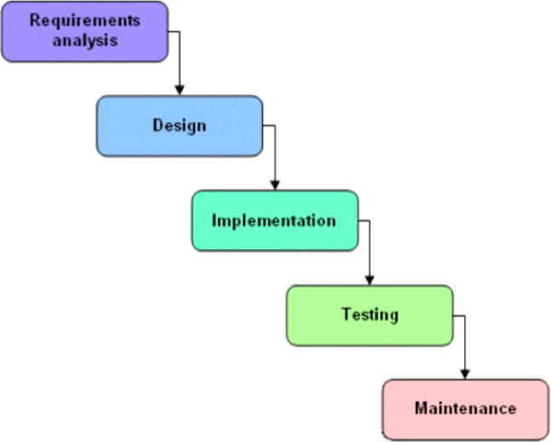

We approached the system development using the waterfall model depicted in the Based on this model, the required estimates have been stated in Annexure. In order to map our estimates with the steps in a waterfall model, we considered each phase separately and then stated the required estimates.

# 

# SOFTWARE REQUIREMENT SPECIFICATION

## 5.1 Project scope

## The proposed work aims to build a website or system with a user-friendly interface.

## The users can get information about their health.

## The users can book an appointment online and visit a hospital accordingly.

## The doctors and users can easily view their medical histories on visits.

## 5.2 User Classes & Characteristics Coder

Registration

Login to application

Setup Profile

Enter medical data

# 

# RESULTS

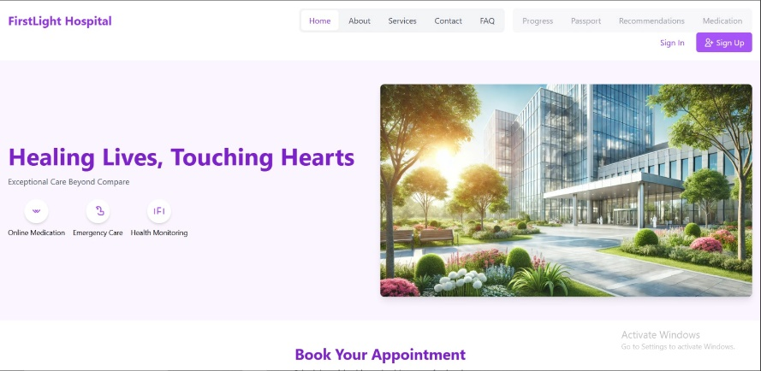

***Home page***

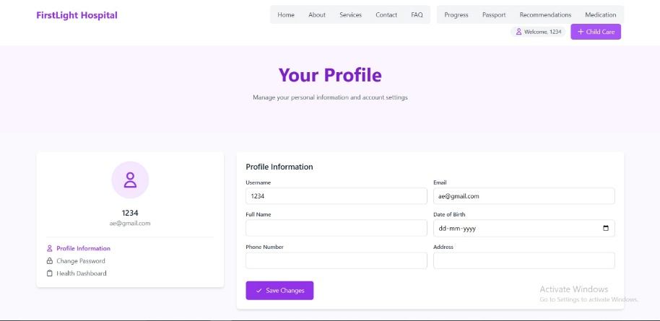

***Profile page***

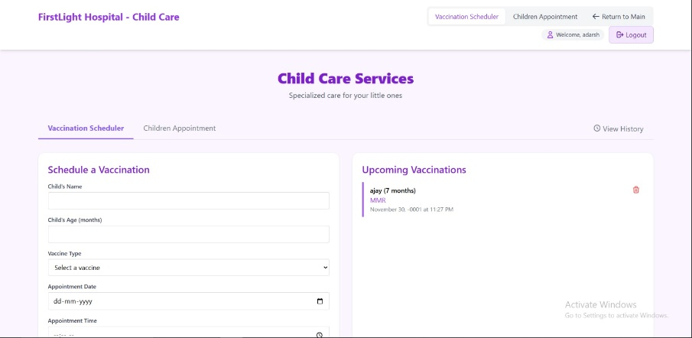

***Child Care Services page***

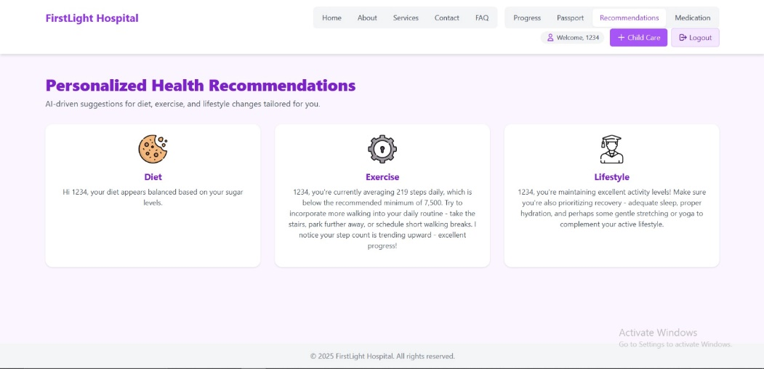

***Health recommendation page***

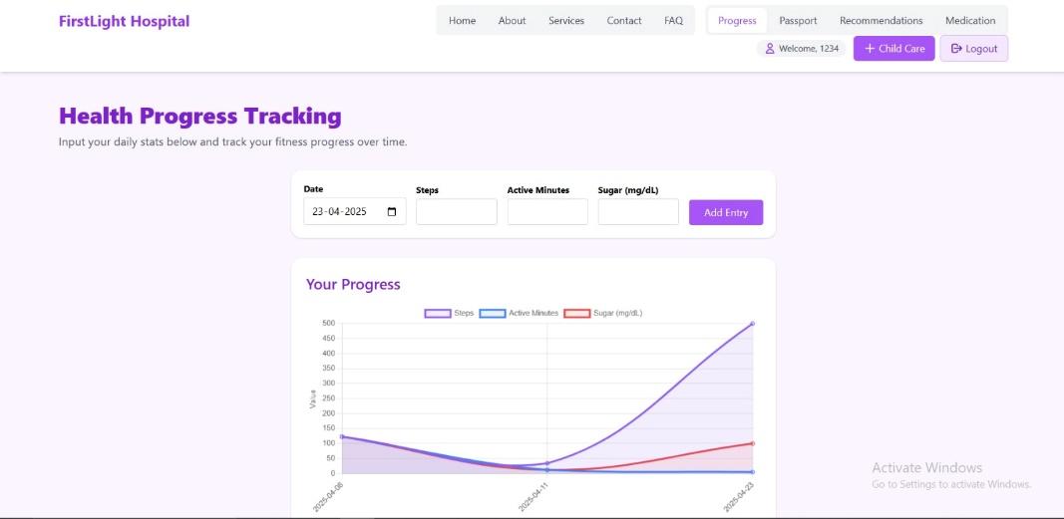

***Health Progress Tracking page***

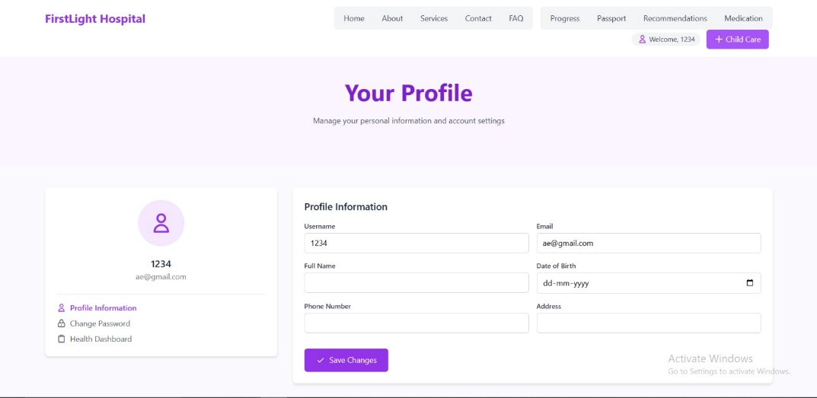

***Online Medication page***

# 

# SOFTWARE TESTING

* A purple and white login page

  Description automatically generatedMail-ID (won’t take values without @)
* Need to login to view Health Passport

* Successfully Update records if valid data

* Confirmation of Booking

* Recorded data is shown on the dashboard

* Mobile interface

# 

# CONCLUSION AND FUTURE WORK

Health Optimizer plays a vital role in modernizing healthcare facilities, improving patient care, and optimizing administrative efficiency.

The insights gained from various studies underline the importance of data-driven decisions and adaptable frameworks in creating sustainable and patient-centric healthcare systems. As technology evolves, future advancements in healthcare management systems will further empower healthcare professionals to deliver high-quality, efficient, and equitable services to all.

In future we can work on:

* Implement automated triage systems to prioritize patient care based on severity and reduce waiting times.
* Expand system capabilities to support telemedicine, enabling virtual consultations and remote patient monitoring.
* Conduct studies to assess the impact of HMS adoption and improve systems based on feedback.
* Use analytics to design more sustainable healthcare operations and reduce environmental footprints.

# BIBLIOGRAPHY

[1]  Assessing the Effectiveness of Healthcare Management Systems in Quality Enhancement by Mamata Devi Mohanty, Pooja Varma, Hemanth Kumar RG, Shivangi Khandelwal, Shankar Lal Soni.

[2] MOPI-HFRS: A Multi-objective Personalized Health-aware Food Recommendation System with LLM-enhanced Interpretation by Zheyuan Zhang, Zehong Wang, Tianyi Ma, Varun Sameer Taneja, Sofia Nelson, Nhi Ha Lan Le, Keerthiram Murugesan, Mingxuan Ju, Nitesh V. Chawla, Chuxu Zhang, Yanfang Ye.

[3] Effect of Mobile Phone Text Message Reminders on Routine Immunization Uptake in Pakistan: Randomized Controlled Trial by Abdul Momin Kazi, Murtaza Ali, Khurram Zubair, Hussain Kalimuddin, Abdul Nafey Kazi, Saleem Perwaiz Iqbal, Jean-Paul Collet, Syed Asad Ali​

[4] The Success of a Management Information System in Health Care – A Case Study from Finland by Tuula Kivinen, Johanna Lammintakanen

[5] A Survey of Issues and Solutions of Health Data Management Systems by Anindita Sarkar Mondal, Sarmistha Neogy, Nandini Mukherjee, Samiran Chattopadhyay

# ANNEXURE A: List of Publications and Research Paper (In its Original formats)

# ANNEXURE B: Plagiarism Report